GYIN GAMBIA YOUTH MENTORSHIP PROGRAMME ON ENTERPRISE MANAGEMENT MONTHLY WORKSHOP SHARING EXPERIENCE REPORT

DATE: 25th-26th JANUARY, 2019
VENUE: TRANS-GAMBIA LODGE AT PAKALINDING, LOWER RIVER REGION (LRR)
This particular Experience Sharing Workshop held in January 2019 at the Trans-Gambia Lodge in Lower River Region, marks the third monthly workshop so far since the commencement of the Youth Mentorship Programme on Enterprise Management 2018/19.
With funding support from the Youth Empowerment Project (YEP), the programme is designed to nurture fifty (50) young people both start-ups and aspiring entrepreneurs on the right path of running a business venture.

DAY 1
ORIENTATION
After the arrival of some of the participants- mentors, mentees and supervisors at the workshop grounds, the GYIN Gambia Executive Director, Mamadou Edrisa Njie welcomed all the participants and gave a rundown of the agenda for the programme.
He explained to them some of the challenges which led to the delay in the programme. After submitting all reports and receipts for retirement, GYIN Gambia awaits YEP to do its verifications so as to effect the second disbursement of funds.
Since the last Experience Sharing Workshop for November 2018, the first 60% funds disbursement was finished. This, according to Njie, has cost some delay in the programme as the workshop for December could not also be held but nonetheless, some of the mentors and supervisors visited their mentees.
In addition, he narrated the struggle that GYIN Gambia has made to secure funds for the continuation of the programme, which include taking an overdraft from Ecobank with some amount of interest rate to be paid. The secretariat has gone to the extent of asking the Mentors and supervisors to do the one-to- one mentoring with their own cost and upon receipt of funds, they would be reimbursed which, they adhered to.
As part of efforts to ensure success in the Youth Mentorship Programme, the secretariat has invented and introduced assessment forms for the mentors and mentees to measure their performances and achievements since the commencement of the programme. After administering the assessment forms, Njie told the mentees about the assessment filling process and those qualify will be certificated at the end of the programme.
He thanked the participants for their participation in the programme and by extension praised the GYIN Financial Controller, Mariam Saine and the entire team for the proper coordination of the mentorship programme.
DAY 2
WORKSHOP

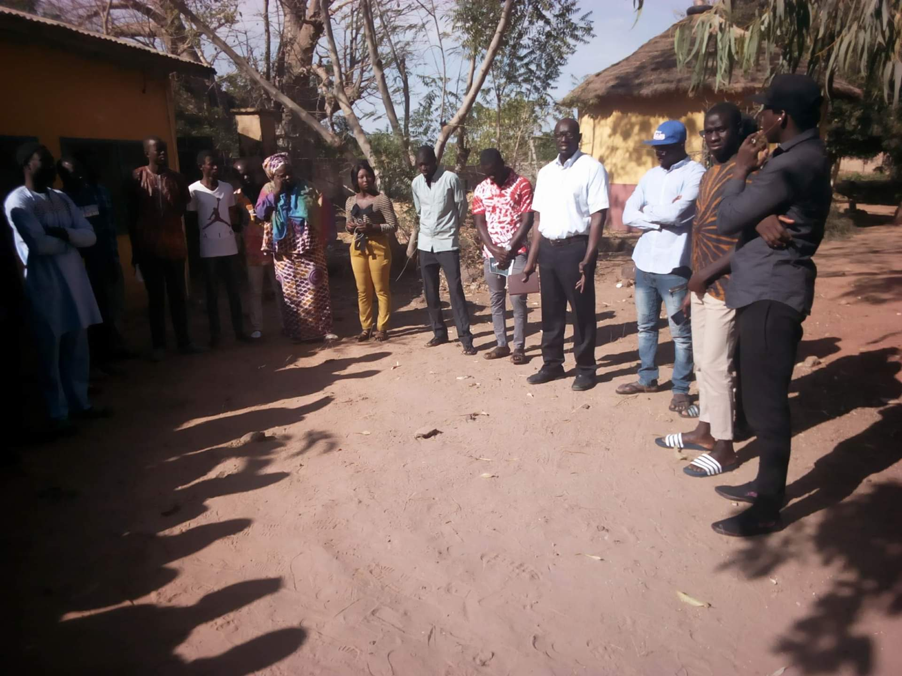
On the day of the workshop, the participants were brought together in one round circle to share their concerns and experiences as per the programme.
Mentors raised some concerns which mentees are facing such as marketing of their products. They also spoke on the important of proper record keeping, budgeting and savings.
Likewise the mentees, they shared some of their challenges affecting their businesses. They raised the importance of having a standard business plan as a business owner to guide your business.
The programme also witnessed filing of assessment forms by mentors and mentees. The forms are designed to be filled every month by the participants and their mentors to gauge their achievements such as accessing the YEP mini grant or mini loan, Business Registration, attending networking events etc.
CLOSING
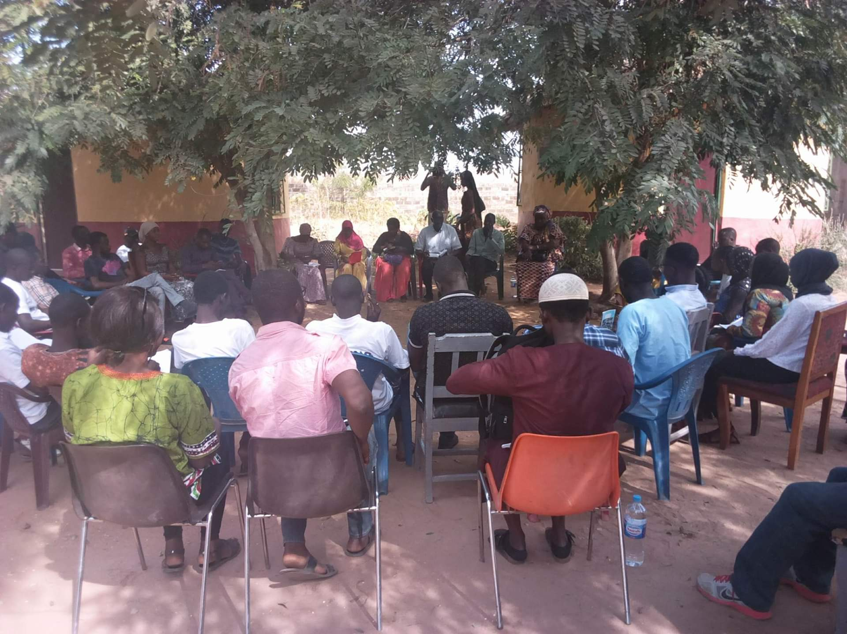
The workshop culminated in a discussion between the participants, mentors, supervisors as well as GYIN Gambia secretariat.

