FOLLOW-UP REPORT ON IDENTIFY YOUTH GROUPS TO ACCESS NEMA MATCHING GRANT
The National Agricultural Land and Water Management Development Project (Nema) in collaboration with the Global Youth Innovation Network Gambia Chapter (GYIN Gambia Chapter) from the 19th – 22nd October, 2018 visited selected youth groups in various regions across the country.
Prior to this visit, the National Youth Council (NYC) and the Global Youth Innovation Network Gambia Chapter (GYIN Gambia Chapter) in partnership with the National Agricultural Land and Water Management Development Project (Nema) embarked on a four (4) days field trip from the 9th – 12th June, 2018 to provincial Gambia to identify youth groups or individuals that can be supported to access Nema Capital Stimulation Investment Fund (CSIF) matching grant.
The Nema and GYIN Gambia Chapter visit was meant to engage the groups particularly those who are into poultry, fish and mango processing and small ruminants to support them access the Matching grant.
The following groups, after fruitful discussions with the Nema Business Development Officer, Mr. Banky Njie, they have decided to change their business ventures.
In all the meetings, Nema BDO clearly explained the objectives of the Nema project thus dwelled more on the CSIF especially the new package that Nema want to implement for youth groups to access the funds.
Mr. Njie also in all the face-to-face discussions with representatives from the organisations executive and general members stated that Nema will support the groups with consultants to develop the business plans for them.
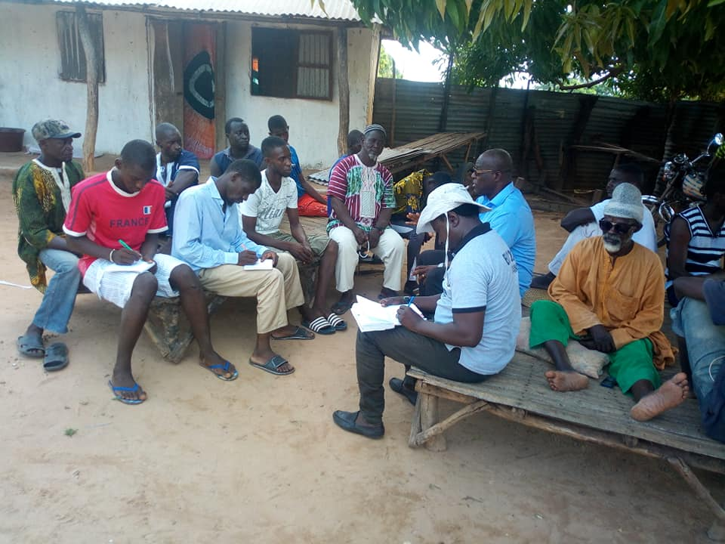
Meeting at Bureng village

He clearly told them that the aim of the support for youth groups to access the matching grant is for them to operate and run profitable businesses.
In addition, Mr. Njie explained the 60%, 30% and 10% contributions of the matching grant stating that earlier, it was 45%, 45% and 10%. He disclosed that it was problem for many youth to access the matching grant simply because they cannot provide a bankable business plans and contribute their percentage.
In the new arrangement, he said that Nema will provide 60%, 30% by a service provider (loan) and 10% contribution by the applicant. These, he said was approved at the Nema Mid Term Review by the donors.
On the value chain, Mr. Njie explained that Nema is now focusing more on processing and marketing, as the project since its inception has supported production of both rice and vegetables.

Nema BDO also explained the difference between running an association and business enterprise, saying they will support them with training programme to be able to run their own enterprises.

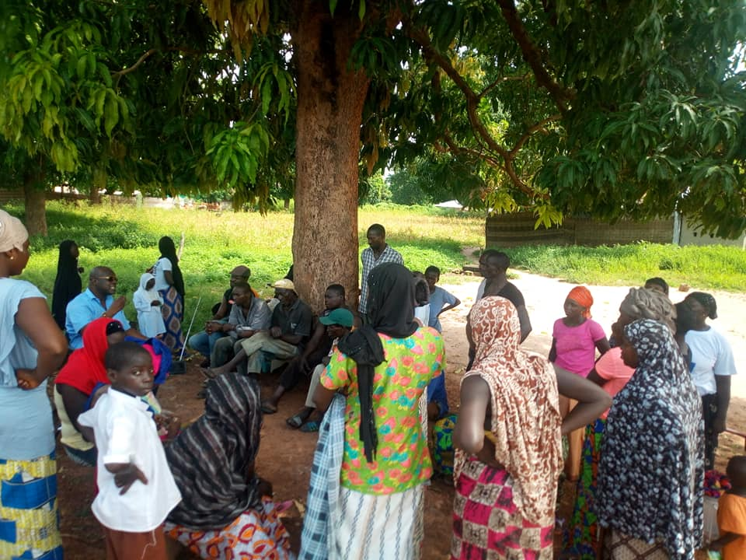
Meeting at Jarra Jattaba village

The following groups identified these ventures during the first assessment
Bureng, Lower River Region | Bureng Youth Development Association | Mango processing
Basse Kabakama, Upper River Region | Kairaba Youth Association | Poultry farm
Basse Mansajang, Upper River Region | Mbaalodiren Youth Association | Youth Abbatoir
Toroba, North Bank Region | Toroba Master Farm | Poultry Farm expansion into value addition.
Kani Kunda Tenda, North Bank Region | KaniKunda Tenda Youth and Social Development Association | Fishing Farming in Value chain addition

The following groups decided to change venture
Bureng, Lower River Region | Bureng Youth Development Association | Rice/Coos processing
Basse Kabakama, Upper River Region | Kairaba Youth Association | Maize processing into poultry and small ruminants feeds
Basse Mansajang, Upper River Region | Mbaalodiren Youth Association | Vegetable processing and storage
Toroba, North Bank Region | Toroba Master Farm | Vegetable processing and storage
Kani Kunda Tenda, North Bank Region | KaniKunda Tenda Youth and Social Development Association | Field crops processing

In his statement during the meetings, GYIN Gambia’s Executive Director, Mamadou Edrisa Njie told the youth groups that the intended support from Nema project should be utilize meaningfully as they are expected to run profitable businesses.
The Nema project, he said, since 2013 has supported numerous youth initiatives which include GYIN Gambia’s Rural Youth Awards, Start-Up Incubation (SIG) Agripreneurs among others.
He urged the youth to work in unison while putting to them that Nema will further provide them with coaching and mentoring as well as other entrepreneurship trainings which will include financial management, records keeping etc…
However, the beneficiaries explained that they are producing lots of rice, vegetables and other field crops and are adding value in their products but lacks support to process their products which include marketing, packaging and branding.
They also lamented how the Senegalese are making profits with their coose and milling machines in their communities.
GROUP SELECTED IN THE NORTH BANK REGION (NBR)
1 | Kerewan village | Operation No To Backway | Vegetables processing machines and storage plant
2 | Toroba village | Toroba Master Farm | Vegetables processing machines
3 | Kani Kunda village | KaniKunda Tenda Youth and Social Development Association | Coose and other field crops milling and processing machines

GROUPS SELECTED IN THE CENTRAL RIVER REGION SOUTH (CRR SOUTH)
1 | Boiram village | Sebosey Platform | Rice milling and threshing machines
2 | Brimaka village | Nyodema Kafoo | Rice milling and threshing machines

GROUPS SELECTED IN THE UPPER RIVER REGION (URR)
1 | Sare Madu Jawo, Wuli | Tamondrial Youth Association | Vegetables processing machines and storage plant
2 | Basse Kabakama | Kairaba Youth Association | Processing maize and field crops into poultry and other small ruminants feeds machines
3 | Basse Mansajang | Mbaalodiren Youth Association | Vegetables processing machines and storage plant

GROUPS SELECTED IN THE CENTRAL RIVER REGION NORTH (CRR NORTH)
1 | Panchang village | Panchang Youth Development Association | Coose milling and field crops machines
2 | Wassu | Rice Production for Development |  | Rice milling and processing machines
3 | Jarumeh Koto village | Bajonkoto Youth Development Association |  | Rice milling and processing machines

GROUPS SELECTED IN THE LOWER RIVER REGION NORTH (LRR)
1 | Kiang Jattaba village | Jattaba Youth Development Association | Rice and coose processing machines
2 | Jarra Toniataba village | Toniataba Youth Dev. Association | Rice milling machine
3 | Jabisa village | Nemasuu Enterprise | Vegetables and rice processing machines
4 | Bureng village | Bureng Youth Dev. Association | Rice and field crops processing machines

ADDRESS AND CONTACTS OF THE SELECTED YOUTH GROUPS
NAME OF VILLAGE | ORGANISATION NAME | CONTACT
Kiang Jattaba, LRR | Jattaba Youth Development Association | Musa Bala 6387492  Landing Sanneh 6686332/ 9964666
Jarra Toniataba, LRR | Toniataba Youth Development Association | Lamin Ceesay:3288859
Jabisa, LRR | Nemasuu Enterprise(Gyiner) | Almamo 3966091  7634668
Bureng village, NBR | Bureng Youth Development Association | Alasan Darboe :3640487  2500294
Boiram village | Sebosey Platform | Hawa Jange 6971829
Brikamaba village, CRR South | Nyodema Kafoo | Borra Kanteh 6258733  Fatou Manjang 3050402
Sare Madu Jawo, Wuli | Tamondrial Youth Association | NafaJ abbai 2169150  Mariatou Jawo 2582720  Mamadou Jawo :2127385
Basse Kabakama, URR | Kairaba Youth Association | Alieu Kebbeh 3424497  Baboucarr Sidibeh:7867248
Basse Mansajang, URR | Mbaalodiren Youth Association | Alagi Muya Jallow  7228838
Panchang village, CRR North | Panchang Youth Development Association | Muhammed Ceesay: 2687515  7873732/7640285  Selou Bah 7222045
Wassu, CRR North | Rice Production for Development | Musa Bah 7032554  Saikou Njie: 6114612
Jarumeh Koto village, CRR North | A group of 5 youth(GYINers) | Diddeh Danso: 6681555/9981555
Kerewan, NBR | Operation No To Backway | Lamin Jawara 6741738  Kawsu Fatty 3804163  Muhammed Singhateh 7408497
Toroba, NBR | Toroba Master Farm | Mr Momodou Loum 7071125  Jaila 3071514
Kani Kunda Tenda, NBR | KaniKunda Tenda Youth and Social Development Association | Modou Cham: 6941651/7894051  Yusupha Ceesay:7922613

