REPORT ON IDENTIFICATION AND ASESSMENT ON YOUTH GROUPS TO ACCESS NEMA MATCHING GRANT
The National Youth Council (NYC) and the Global Youth Innovation Network Gambia Chapter (GYIN Gambia Chapter) in partnership with the National Agricultural Land and Water Management Development Project (Nema) embarked on a four (4) days field trip from the 9th – 12th June, 2018 to provincial Gambia to identify youth groups or individuals that can be supported to access Nema Capital Stimulation Investment Fund (CSIF) matching grant.
The trip, which have included sensitization and face-to-face meeting with youth groups, will enable youth groups as well as individuals to be supported by Nema to develop a bankable business plans to get funding support from the grant. The team comprised of NYC and GYIN Gambia.
It has been observed that many youth groups are producing lots of rice, vegetables and other agricultural products and are adding value in their products but lack support to process their products which includes marketing, packaging and branding. Therefore, the programme will assist youth groups (including women) as well as individuals to accessing the matching grant which happened to be a major challenge for the Nema project. It has been noticed that only few youth groups or individuals benefitted from the grant.
Therefore, this programme will address the gaps in the matching grant by identifying active youth groups to develop a business plan that will attract funding thus support them to improve their livelihoods and expand their business to generate incomes. Their business on the other way around will also be a profitable business and to be a sustainable venture.
Furthermore, the importance of business partnership and shareholders in business will also be discussed to enable them to work in unison and in that way, it will promote cooperation among themselves as young people.
NORTH BANK REGION
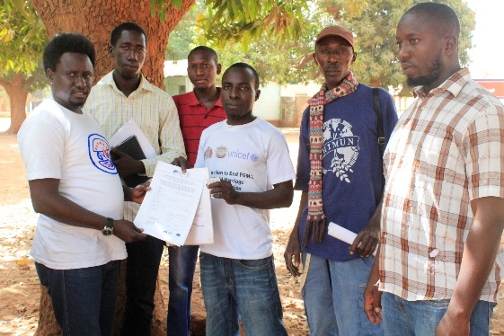
The first team we had interactions was in North Bank Region called the Operation No Way to Backway NBR chapter. The organization has two hundred memberships and surprisingly the greater chunk of it being females. The association is banking with Reliance Financial Services with more twenty thousand dalasis (D20, 000.00) in their account and their interest area is on processing of vegetables.
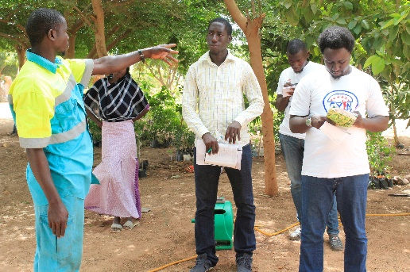
The current available resources of the association is a land of 67m by 72m on the Kerewan highway, woodlood in Saba village and a beekeeping hive equally in Saba.
They plan to serve as the first market for the raw materials from the gardens which they will utilize through their storage and preservation store to support their processing. The needed resources as outlined during the discussions are Power tiller, wheelbarrow, borehole, cold store, processing store and fencing of the garden.
TOROBA VILLAGE
The next stop in NBR was in Toroba village where the team met with a dynamic young man by the Momodou Loum who is currently having a mixed farming unit at the outcast of Toroba village towards Njawara village. Mr. Loum has been trained at the Njawara Agricultural Training Centre in NBR and currently, he is utilizing the knowledge gained to train some youth from Toroba village and it’s surrounding on Poultry, nursing making and horticultural gardening for the past two years. The current available resources at his disposal are a borehole, land of 1.5 hectares, constructed poultry house which can take almost four hundred chicks. According to him, he needs a big solar system to support his processing and preservation of the garden products, Chicks for his poultry house. Mr. Loum assured us of counter contribution and potential employment for almost hundred youth on his master farm.
KANI KUNDA TENDA
Third community visited in North Bank was Kani Kunda Tenda which is 27 km from Farafenni and 19km from the main high way. The village is close to the river Gambia and their main focus is on Fish farming and groundnut Production. The KaniKunda Tenda Youth and Social Development Association have more than one hundred and forty membership both in the village and in the urban areas. Their available resources in the village at the moment are three fishing boats, one from CDDP, IOM and Ministry of Fisheries of The Gambia which is currently having nine youth employed there.
The association wants to focus on fish value chain production and needs smoking facilities, drying facilities, cold store and a transport facility alongside a capacity building on the usage of the fishing machines.
CENTRAL RIVER REGION NORTH
PANCHANG
After completion of North Bank Region the team moved to the southern part of Central River Region and the first community was Panchang. The Panchang Youth Development association with a membership base of one hundred and eighty (180). They shared constraints and success stories of the association towards the development of their village ranging from their contribution in the education sector, health and village social and traditional activities human resources and financial supports. Currently, the association has 50/50 land for farming and a designed fish pond which is still pending by FASDEP. The youth leaders during the discussion pleaded for thrashing machine and a tractor to support their farming production in the sector value addition.
WASSU
The team met with Saikou Njie in Wassu CRR North who is the team leader of a ten committee membership group with similar ideas on the value addition initiative. The team equally wants to have tractor and a milling machine to support their production, milling of home grown rice and transportation of the rice to various marketing sites for proper marketing. As part of milling the rice, they will also be doing packaging and labeling of their milled rice.
JARUMEH KOTO
The next stop was in Jarumeh Koto village in CRR North were the team met another team leader of five group membership and they are also interested in Rice production and milling because they have more than 15 villages in their surrounding who are not doing rice production so it is outlined during the meeting that the team will have a good delivery sites to supply rice when given the necessary support. The team needs a tractor and a milling machine that will support their production.
JANJANGBUREH
JUST ACT
The next team we met was Just Act Youth Group in Janjanbureh in CRR South who are doing animal fattening and currently they have 50 small ruminants and they need support in that sector to do value addition on that.
The association request for small ruminants, packaging and cold store for their meats. They assured us of a good bank account and active human resource.
UPPER RIVER REGION
TAMONDIRL YOUTH ASSOCIATION in English “Togetherness”
The first meeting in the Upper River Region was with an association called Tamondirl Youth Group in Sare Mudu Jawo Kunda in Wuli East. The association has more than two hundred membership and is interested in vegetable gardening. They have 2-4 hectares of land, community support and a reliable market because many villages in their surrounding are suffering in terms of preserving their products from the gardens. The village is closer to Senegal. Many a times, they sell their vegetables at a nearby village “Lumoo” in Senegal at a cheaper price.
They requested for fencing, borehole, storage facility, processing facility and solar panels to support their garden for value addition. They assured the team of their counterpart contribution of which they said would not be a problem and equally outline slow response from the projects. The youth association is ambitious that they can manage a successful business if supported.
KAIRABA YOUTH ASSOCIATION
The second meeting was with Kairaba Youth Association in Basse Kabakama currently engaged in poultry farming. The association currently has 20 by 10 constructed poultry house and thirty sheep at their disposal. They are requesting for feed processing machine, fencing the poultry house, bore hole and electricity.
They equally pleaded for capacity building on feed processing and additional poultry management skills. The association has a good membership base of more than one hundred youth. The association is requesting for a support to produce poultry feed and supply all the poultry farmers in the country. According to them, the land is available for them to cultivate corm and would therefore, need machines that would process poultry feeds.
MBAALODIREN YOUTH ASSOCIATION
The third association the team met in URR was Mbaalondiren Youth Association. They are currently doing animal fattening and want to start “A YOUTH ABBATOIR” in Upper River Region. Their current available resources are land, 25 sheep and 5 goats. The association is requesting for a cold store, slaughtering room and packaging machine for their value addition initiative.
CENTRAL RIVER REGION SOUTH
BOIRAM
The first community that the team visited in the southern part of the region was Boiram village which is a wollof community. During a discussion with the team leader, he said their area of focus is on rice production & processing and packaging of community rice from their village and their neighboring villages since rice is the main crop production in that area.
The team comprises of five youth from Boiram responsible to take up this value addition initiative and they equally assured of counterpart contribution. They are interested in milling machines. They also recommended for Brikama to have a milling centre.
BRIKAMA BA
Brikama Ba was the next stop in CRR South and the team had a meeting with Brikama Ba Nyodema Kafoo on Rice production. They currently have 2 hectares of land but their challenge is processing and branding their rice. The team pleaded for milling machine and packaging to support their value addition programme.
LOWER RIVER REGION
BURENG
The next region was lower River Region were the team had a meeting with Bureng Youth Development Association under the leadership of Mr. Amadou Darboe. The association has a membership of more than two hundred (200) youths who are currently engaged into many village development programs but they identified mango processing as their area of interest in the value chain addition programme.
The village currently has an orchard with forty mango trees and 23 cashews. They are requesting for processing machine, cold store and transportation. The association assured the team of a healthy account with Trust Bank.
JARRA SOMA
The next community visited was at Jarra some, were the team met had a meeting with the founder of Nemaasuu Enterprise ltd which is a youth led business at Soma. The enterprise wants to take up vegetable processing as their value chain production and they are requesting for processing machine, cold store, packaging and cold store.
JARRA TONIATABA
Toniataba which is few kilometers away from soma was also visited and the team had a meeting with Toniataba Youth Development Association. The association is actively engaged in the development projects of the village ranging from the self-sponsored village health post, primary education and community set setals.
The association requested for milling machine and packaging since rice is their major crop produce in the village and its surrounding but processing is always the problem. They have a membership of more than two hundred (200) and assured the team of counterpart contribution.
JATTA VILAGE IN KIANG
The last stop in Lower River Region was in Kiang Jattaba were the team had another meeting the Jattaba Youth Development Association. The association is another vibrant youth group championing village development projects such as initiating an Arabic school, tree planting, supporting the village traditional and social event financially and human resource.
They have several hectares of land in the village with a membership of more than four hundred (400) youths. They are requesting for a multipurpose milling machine to support their rice value chain initiative. The youth group wants to venture into mango processing as their second priority and fish farming.
WEST COAST REGION
The last group to be visited was Kombo South in Tanji. The youth led group call the ACTUARIANS composed with ten young men who are all graduates from the University of The Gambia (UTG) and are interested in poultry business. They have the land and developed business plan on poultry. They are requesting for support with cold store, construction of a poultry house, defeathering machine and packaging machine.

OBSERVATIONS FROM THE FIELD TRIP
- Many of the youth groups/association visited are ready for business
- All of the groups/associations visited can make counterpart contribution
- The groups/association are already in the value chain
- They need machines/structures to transform their products/produces etc
- All the groups/associations visited have active membership

RECOMMENDATIONS:

- Identify a consultant to develop a business plan for the groups/associations
- Timely disbursement of the Nema 60%
- Training for the CSIF Grantees
- Coaching and mentoring for the CSIF
- Regional exchange visits for the CSIF Grantees

