GYIN Gambia Youth Mentorship Graduation Report
The Global Youth Innovation Network Gambia Chapter (GYIN Gambia Chapter) with financial support from the Youth Empowerment Project (YEP) on the 10th February, 2018, held a graduation ceremony at the Rural Development Institute (RDI) in Mansakonko, Lower River Region.
The graduation marked the completion of the three (3) months Youth Mentorship Programme on Enterprise Management for twenty-five (25) young people.
The graduation brought together mentees, mentors, YEP, Nema project, Ministry of Agriculture, family members of the mentees, students, scout band, and other invited guest.
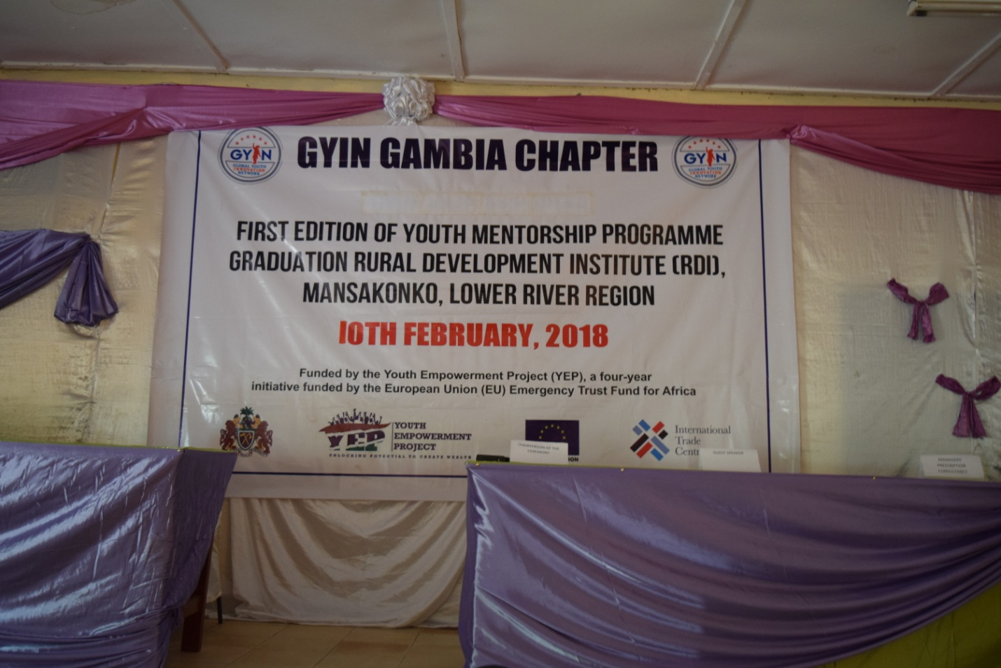
GYIN Gambia Three (3) Youth Mentorship Programme is funded by YEP Gambia
The aim of the mentorship programme is to boost Gambian rural entrepreneurship and agribusiness. The programme supports young people in their efforts to establish sustainable investments in order to become self-reliant. It is anchored on coaching and career counselling rather than the single method of structured trainings.

The mentoring programme is a part of a larger entrepreneurship development programme that includes recognition of young entrepreneurs through yearly Rural Youth Awards and specific training camps for upskilling young and aspiring entrepreneurs.
Speaking at the graduation ceremony, Raimund Moser, Project Manager, YEP The programme enlisted twenty five young people who went through an intensive three months mentoring on enterprise management with support from the Youth Empowerment Project.
He noted that the idea resulting to the support from his project is the potential in the mentorship programme to earn more young people good share in local and global markets. Judging by the graduation trend, he said the cycle of mentorship will eventually entangle the entire youth population if the mentees become mentors and mentors become supervisors.
The YEP project manager encouraged the graduands to build on their business foundations and take advantage of the grand initiative through his office meant to reinforce the efforts of young people in the Gambia.
Raimund Moser, YEP Project Manager

In his introductory remark, the Executive Director of Global Youth Innovation Network, (GYIN) Gambia chapter, Mamadou Edrisa Njie said that the graduation represented a successful pilot to a larger component of youth mentorship business in the country. He remarked that enrolment to the mentorship programme was opened to young people who have once attended either of the Entrepreneurship, Leadership, and Information Technology (ELIT) summer camp; Rural Entrepreneurial Venture Creation and Experimental Learning (REVCEL) as well as Rural Youth Award (RYA) finalists, all powered by GYIN – Gambia; or proof of training on business fundamentals from any recognised institution within or outside the country.
He embraced the support the European Union (EU) through the Youth Empowerment Project (YEP) and partnership with the Managers’ Prescription Consultancy Firm on the programme.
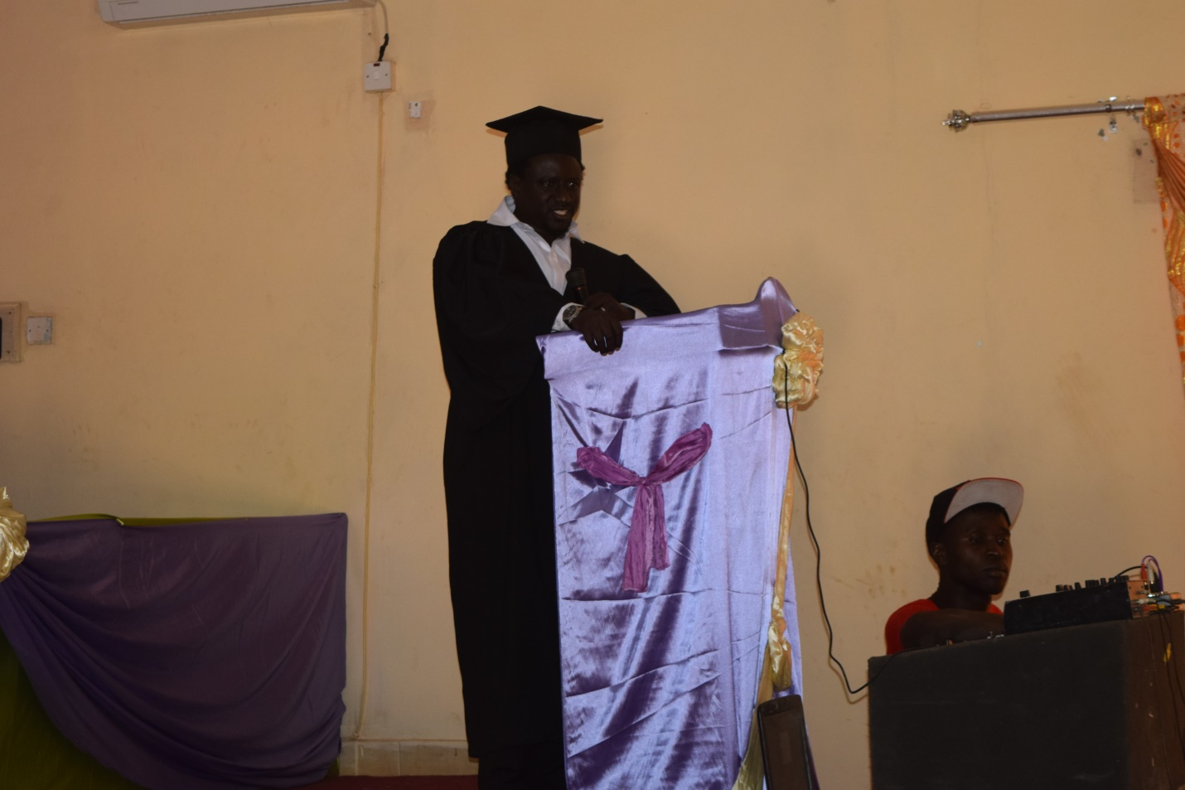
Ambassador Mamadou Edrisa Njie, GYIN Gambia Executive Director

The guest speaker for the occasion, Musa Bah who is Senior Education Officer (SEO) at the Regional Education Directorate in Mansakonko, and recently appointed Justice of Peace (JP) said it is out of his knowledge that GYIN – Gambia has clear goals and realistic vision. He stated that the association’s activities are in line with Sustainable Development Goals such as the target to end poverty, hunger, promotion of agriculture, and promotion of good health and wellbeing.
The educationist cum Justice of Peace asserted that mentorship being a professional relationship between a more experienced person and a mentee who is less experienced is a performance oriented teaching and learning process.
“One of the most important aspects in mentorship is the hope it gives to young persons on the availability of resourceful persons who care about them. As a result, the mentee is compelled to meet all expectations on the subject of the mentorship.”
While noting that developing countries such as the Gambia needs to adopt mentorship programmes as part of its development agendas, he challenged the graduands to translate their skills into actions.
Speaking on behalf of the implementing partners, Ousman Sonko, the Managing Partner of Managers’ Prescription Consultancy Firm stated that the three month long exercise has recruited fully fledged mentors on business enterprises.
He said the task being first of its kind for his team of trainers, was not smooth as it required meeting of complete coverage of the training modules, and thorough attention to mentees’ individual case differences.

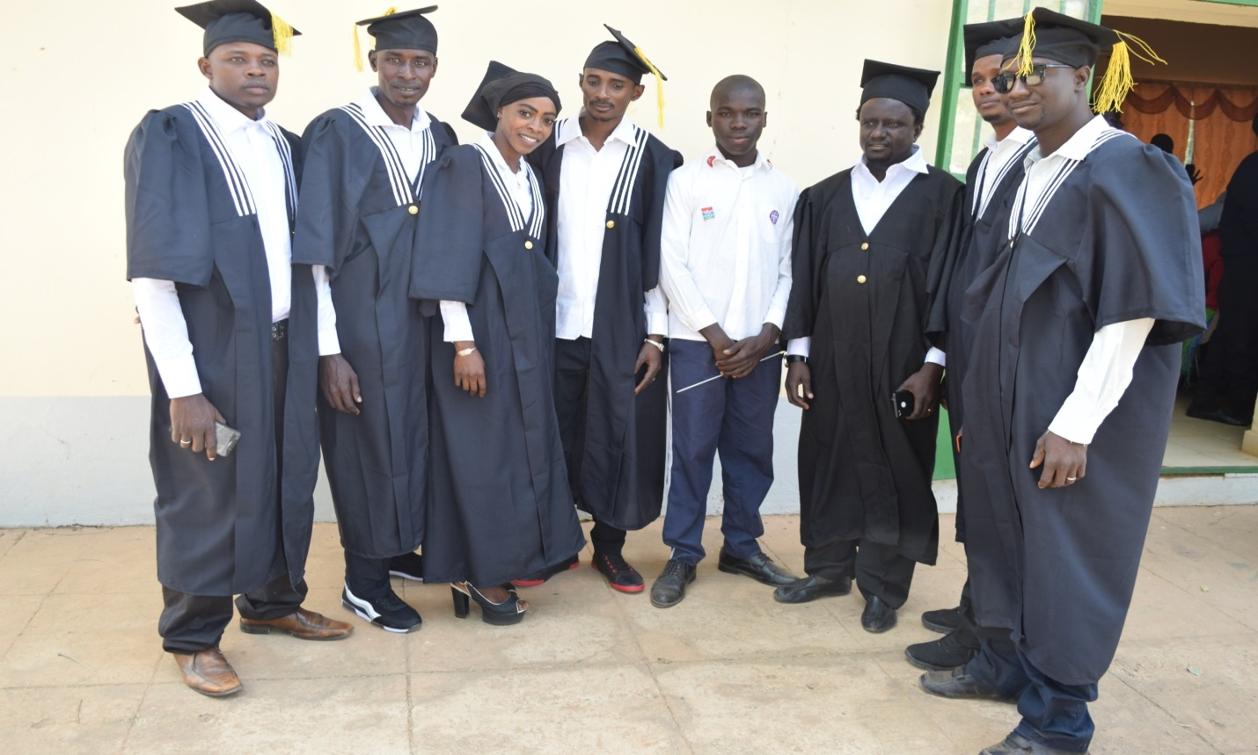
Rural Youth Mentors

Mr Sonko expressed conviction that the trained mentees are prepared to give mentorship services and improve on their own business perceptions irrespective of given resources and challenges.
Speaking on behalf of Nema-Chosso, Mr. Banky Njie, Business Development Officer (BDO) expressed delight in the programme saying that GYIN Gambia in partnership with YEP has successfully implemented the recommendation made during a daylong training on Entrepreneurship and Skills Development at the 2017 First Ever Rural Youth Award 2017 by conducting a three months Youth Mentorship Programme.
“It’s good that GYIN Gambia has implemented a key recommendation from the rural youth award by successfully completing a three months youth mentorship programme on Enterprise Management funded by YEP.”
He added that the inclusion of rural youth in decision-making and celebrating their successes is a priority for GYIN Gambia which, he according to him, is also priority for Nema-Chosso project.

The Nema project, he explained, is also funding the Agricultural Value Chain Interaction Platforms (AVIP) Project which is a two years project. The AVIP Project is being implemented by the West Africa Rural Foundation (WARF) based in Dakar, Senegal in partnership with GYIN Gambia Chapter. The goal of the AVIP Project is to contribute to the achievement of key Nema outcomes by establishing operational and functional women and youth-based agricultural value chain innovation platforms (AVIP) with secured access to profitable local, regional and national markets.
Through the project, he disclosed that 100 young (men and women) benefiting from Nema intervention will realize increased rice and vegetable productivity and participate effectively and profitably in national and regional markets. Producer organizations, including youth enterprises will have increased access to financial and non-financial services through improved interactions with other actors of selected value chain interaction platforms.
Fatou Mbenga Jallow, Presenting a certificate to Mr. Kemo Saho

Coming back to the mentorship programme, at Nema, Mr. Njie said they believed that this mentorship is important simply because it will increase the recognition of youth in the rural setting.

Finally, “I would like to say a big thank GYIN Gambia Secretariat and Managers Prescriptions for successfully implementing this programme”, he concluded.

