AVIP RICE PLATFORM MEMBERS WITH NEMA PSU, CONTRACTORS AND ENGINEERS

WEDNESDAY 28TH JUNE 2018

AT NEMA CONFRENCE HALL ABUKO

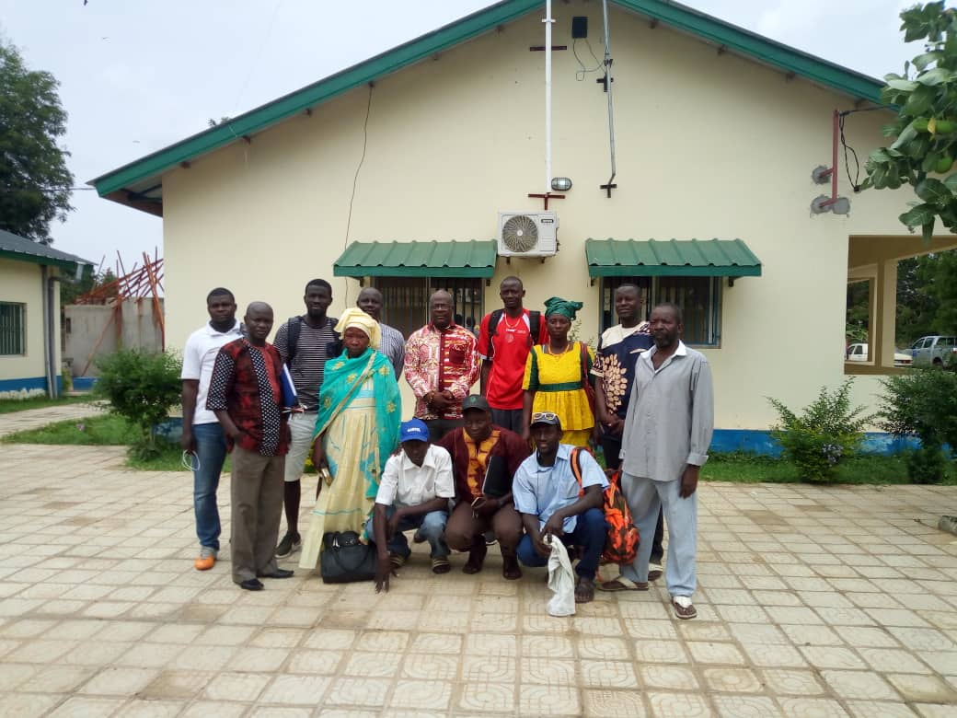
A GROUP PHOTO (28TH JUNE 2018)

Introduction
The main focus of this meeting was centered on the concerns of the AVIP rice platform entry points as indicated during the launching of the platforms Mr. jarra in his introductory remarks reminded the participants to focus on the entry point problems so that the PSU can be fully aware of them and try to sort solutions further urge the PSU staffs to take note of their concerns as they are very important issues hindering the operations of the platforms, he then welcomed all the participants and assured them that let them feel free to voice out any concern and ask questions where necessary to clear their dough.
Mr Paul mendy also highlighted the importance of the meeting as a forum of interaction between the platform members and project staffs, he noted that such interactions creates better communication and understanding he thanked all participants for coming on time.
Mr Ensa colley in his closing remarks on behalf the project Director told participants that the Director was very concern and interested in this meeting this is why he took no time in the facilitation this the that accord him the opportunity to hear farmers concerns and how to better provide solutions, however he express his disappointment as to how the contracts works were delayed by the contractors and supervising engineers he assured the members that all efforts will be made to finish the incomplete works and rehabilitations because contractors payments are not fully paid
Mr colley on behalf the Project Director thanked all the participants for their patience and cooperation.

As during the horticulture meeting platforms were allowed to come up with their concerns
Boiram
- Equipment/machinery production, processing quantity and quality seeds and fertilizer
- Storage facility
- Processing center
- Support with cash to buy the products(harvest)by the cooperative and retail to make a margin
Response by the PSU knowledge management officer
- Provision of cash he said the farmer organization has D1.3 million in their account enough to invest in their farming activities
- Equipment—he said the equipment management framework is already developed and the project is already providing this for them
- Storage – storage facilities will be provided for them
- Upstream value chain processing facility to be provided
- Boiram already supplied with seeds and fertilizer(supplies already in sapu to be collected by next week)
- Information sharing within the platform members required for awareness

Pakalinding
- Pakalinding rice field is 200ha and the project and project access road only facilitates only 45% of the beneficiaries, another road to( SULU BOLONG)required to create access for the larger 55%
- Internal access roads in the rice fields are not available
- Skills training in GAP adoption to improve production and productivity.

Kudang
- Seeds, fertilizer and equipment
- Advance training skills and promote adoption of GAP and effective commercialization methods
- Tractor ploughing required soonest before heavy rains are experienced

Action points
- Seed distribution and fertilizers to begin next week
- Production, processing and marketing equipment at PSU level
- Field trip to harmonize AVIP and FOs after 17th june 2018(joint visit KMO,BDO and AVIP core team
- All platform members to join the FOs AVIP core team and KMO&BDO to embark on joint visit to each of the rice platforms to convince the 18 executive members of the FOs and the 18 AVIP members to harmonize the objectives of both which are meant to complement each other
- Ensa to followup with DOA on the distribution of P2RSseeds and fertilizers and communicate outcome to the platforms by Friday the 29th of June 2018
- Ensa to contact Musa Bayo for the Nema allocated tractor to assist ploughing for AVIP members at kudang

Conclusion
The meeting ended successfully all points were noted by the project staffs as the problems of the rice platforms do not significantly all the problems were answered the project promised to take care of their concerns

ANNEX
LIST OF PARTICIPANTS
NO | Names | Institutions | Contact numbers
1 | Bakary Jammeh | Nema Chosso | 3347302
2 | Bakary EK Jammeh | Nema | 3329303
3 | Banky Njie | Nema | 3529292
4 | Lasana Jarra | AVIP | 7202423
5 | Lamin Jasseh | Consultant | 70979800
6 | Paul L Mendy | AVIP focal point | 9267250
7 | Ensa Colley | Nema Chosso | 9992512
8 | Fanta Boye | Boiram | 2448773
9 | Ali Boye | Boiram | 7938259
10 | Ebrima Susso | Pakalinding | 6778125
11 | Bakery Seedy Ceesay | Pakalinding | 6980464
12 | Sainey Camara | Kudang | 6809855
13 | Mamadi Danso | Kudang | 6958759
14 | Sarjo Jarju | Facilitator/Kudang | 7804805/6692355
15 | Jainaba Manjang | GYIN Gambia | 2865563/340760
16 | Bassiru Fofana | Co-facilitator/Kudang | 3748333/6748333

